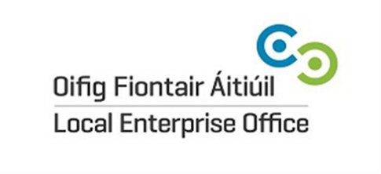
Application Form
National Enterprise Awards 2017 - Louth
Name of Applicant: Click or tap here to enter text.
Address: Click or tap here to enter text.
Click or tap here to enter text.
Region: LOUTH
Legal Status: (Tick one) Sole Trader ☐ Partnership ☐ Limited Company ☐
Date of Commencement of Business: Click or tap here to enter text.
Phone. : Click or tap here to enter text. Mobile: Click or tap here to enter text.
Website : Click or tap here to enter text. e- mail: Click or tap here to enter text.

Business Information
What product or service do you supply?
Click or tap here to enter text.

Describe your own background and why you set up in business?
Click or tap here to enter text.

What do you see as the key strengths of your business?
Click or tap here to enter text.

In what way and when, did your Local Enterprise Office help you (formerly CEB)? (Please include the year, type and level of support i.e. Grant aid and /or Training Supports)
Click or tap here to enter text.

Has this business been grant aided by any other government agency such as Enterprise Ireland, An Bord Bia, Leader Partnership, Inter Trade etc (If so give details i.e. Agency, Year, Grant Amount, Type etc)
Click or tap here to enter text.

Marketing Your Business
Describe what is different or innovative about your product or service?
Click or tap here to enter text.

Is your customer base local, regional, national, international? Please give details.
Click or tap here to enter text.

How do you market your business?
Click or tap here to enter text.

Are there potential new markets for your business and how do you plan to take advantage of these opportunities?
Click or tap here to enter text.

Social Media
What forms of social media do you use to promote your business and describe any campaigns you have Undertaken?
Click or tap here to enter text.

Technology
How do you use technology in your business?
Click or tap here to enter text.

The Future of your Business
What long-term plans do you have for your business and how do you see it growing and developing over the next 3 years?
Click or tap here to enter text.

What do you see as the key threats/weaknesses to your business? How do you propose to address them?
Click or tap here to enter text.

Employment Details
 | 31/12/2014 | 31/12/2015 | 31/12/2016 | Projected 2017
Full Time
Part Time

Financial Details
Business Growth | Year 2014 | Year 2015 | Year 2016
Annual Sales
Net Profit

Investment | Year 2014 | Year 2015 | Year 2016
Own Funds
Loans
Grants
TOTAL

Closing Date for applications is 5.00pm Friday 17th February 2017.
Please return your completed application form, together with a current Business Plan and financial statements to Local Enterprise Office Louth, Town Hall, Crowe Street, Dundalk, Co. Louth.

Signed: _________________________________ Date: ____________________________________

